
Arab Academy for Science, Technology and Maritime Transport
College of Computing and Information Technology
Department: CyberSecurity

Course: Operating Systems

Assignment: OS Lab project

Lecturer: Dr.Eng. Mahmoud M. Ismail

T.A: Mohamed Osama Mohamed Badawi

Name: Mohamed Elsayed Mohamed Khayami

Reg#: 221010750
Date: 30/12/2024
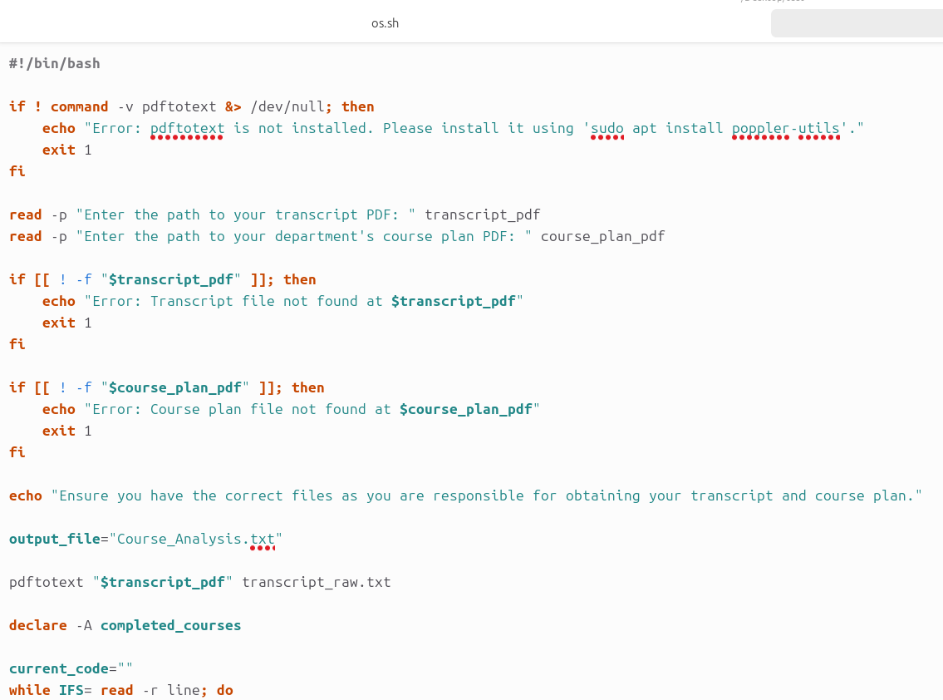
The Script:

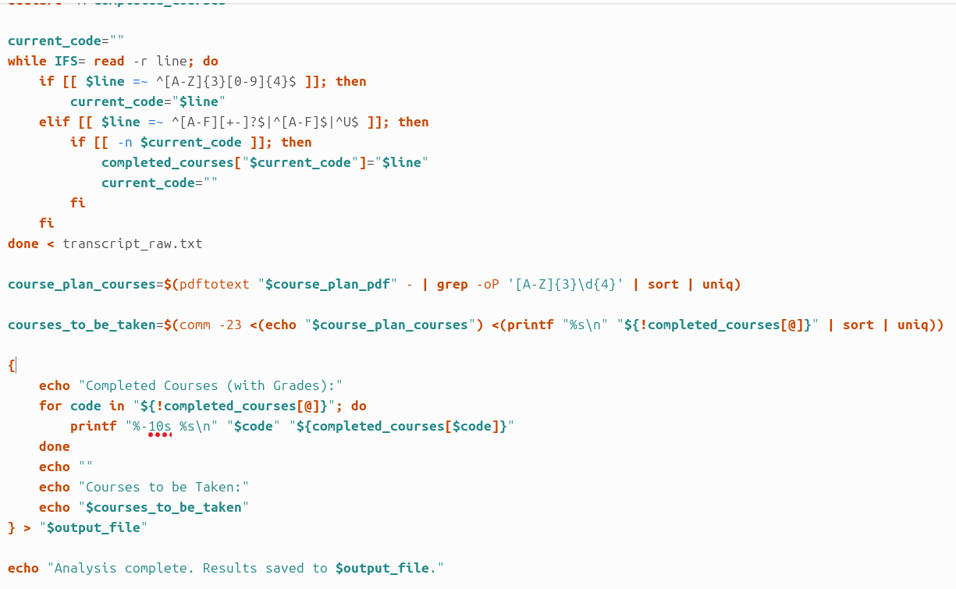

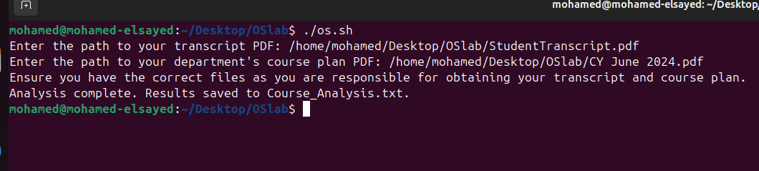
AA The Output:

